QTRAK Network Share Connection Break
- Check the list of servers. Refer system_catalogue.xlsx to get the Windchill NA QA server hostname as below –
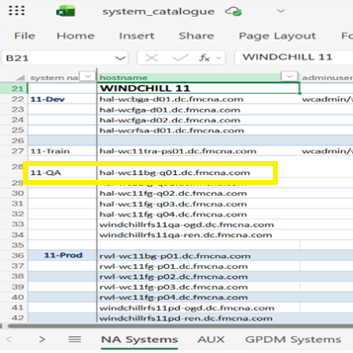
- Connect to Citrix VDI using your FMC email ID/password & MFA.
- Login to CyberArk (using FMC credentials) directly from the URL below or it can be accessed from FMC app dashboard -
https://fmcsecurelogin.fmcna.com/PasswordVault/v10/Accounts
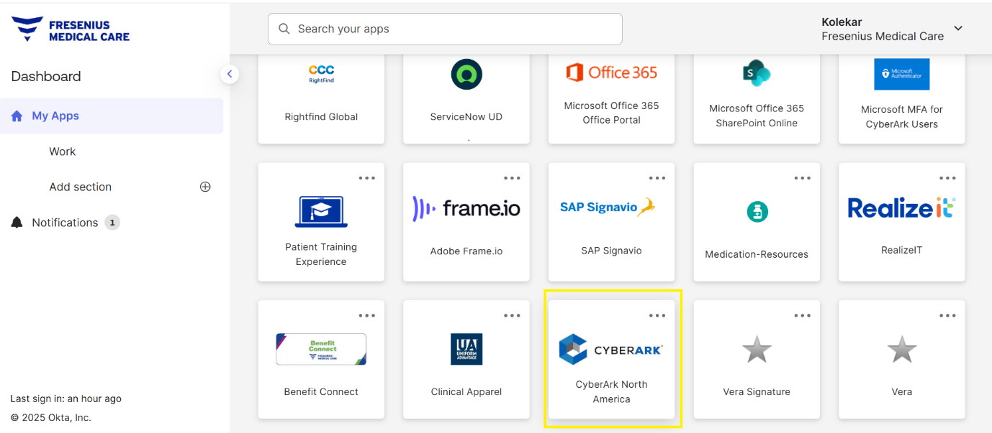

- Search the servers in CyberArk –
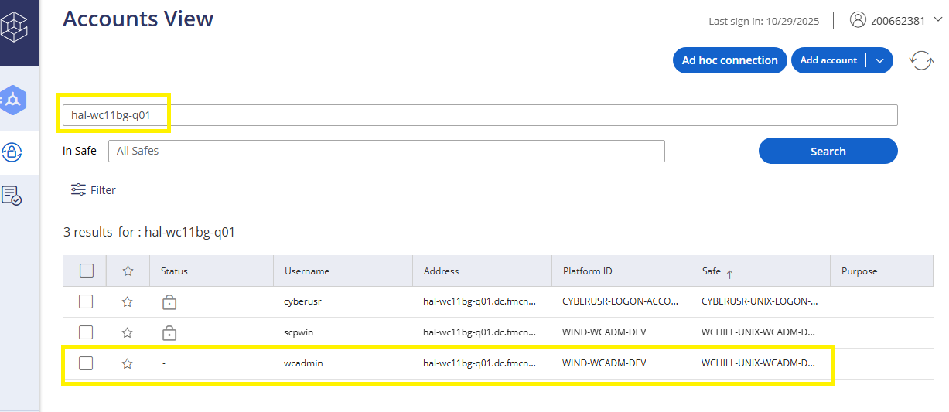
  - Select Keep in downloads & connect to “ hal-wc11bg-q01.dc.fmcna.com “ as ‘ wcadmin ’ Administrator user.
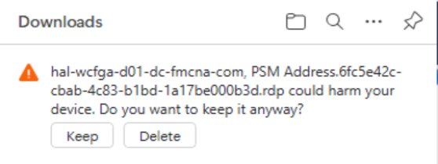
The QTRAK share reconnection Steps:
    - Navigate to the bin directory:
- This command changes the current working directory to bin, where the script files are located.
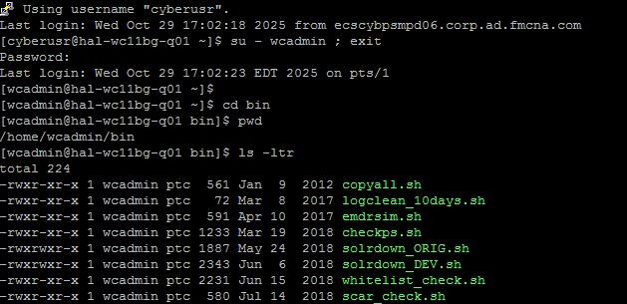
    - List files in bin directory:
- Verify that ‘ reconnect_QTRAK.sh ‘ exists in the directory.

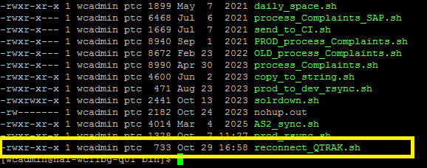

    - Commands to use entering in QTRAK Shell:
- sudo -l
- sudo ./reconnect_QTRAK.sh
- After running this command asks for password
- The password is validated from the system catalogue file.
Expected output:
QTRAK MOUNT: VALID
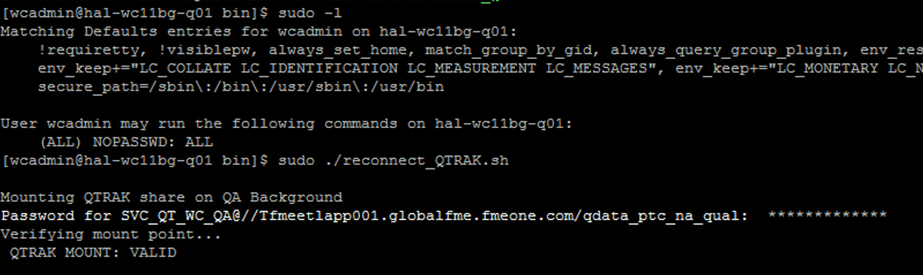
To Cross Check Commands to Use:
- cd /windchillvault/
- ls -lr
Check if “ QTRAK_Share_qa “ is present.
  - If the folder name appears green, it is active (mounted).
  - If it appears blue, it is inactive (not mounted).
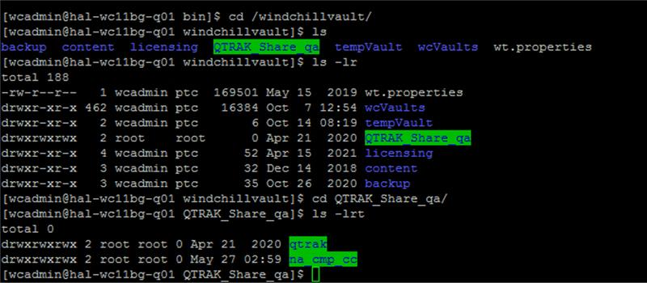
To cross check again use following commands:
- cd QTRAK_Share_qa/ :
  - Moves into the ‘ QTRAK_Share_qa ‘ directory.
- ls -lr :
  - Lists the contents of QTRAK_Share_qa.
- If files are present → Connection is successfully established.
- If the folder is empty → Connection is not established.

